Lab 3
Task 1
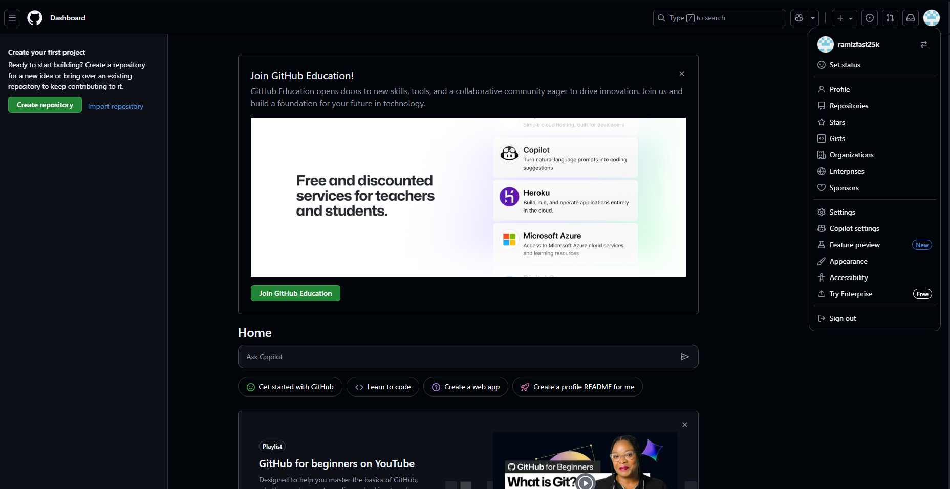

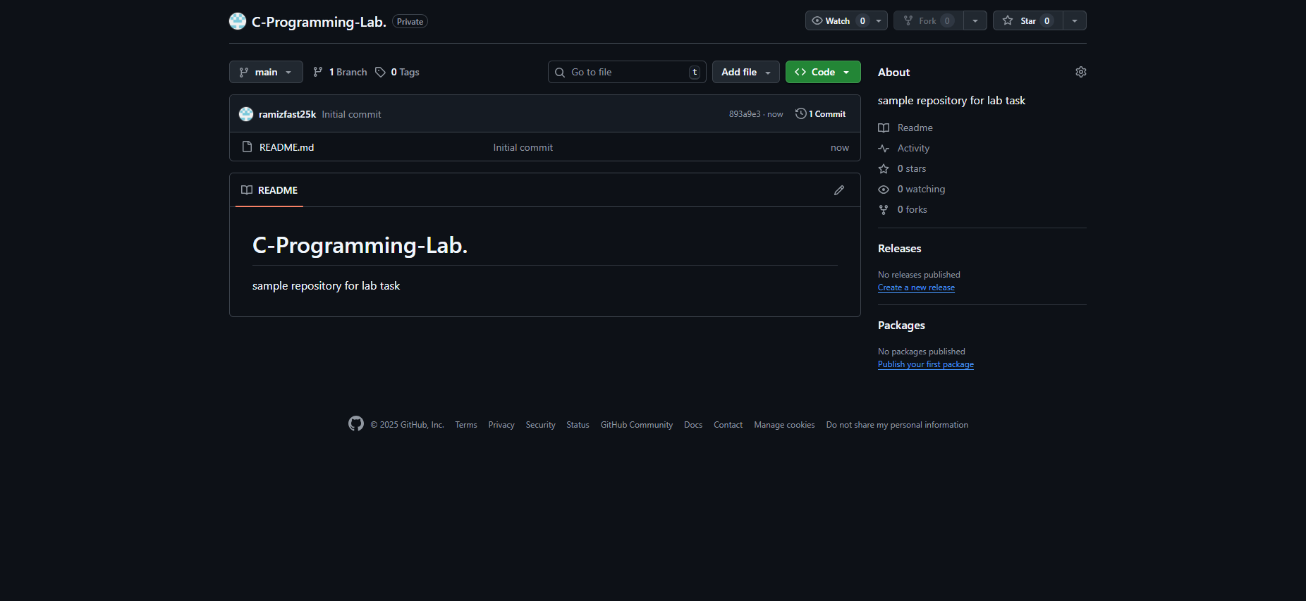
https://github.com/ramizfast25k/C-Programming-Lab.

Task2

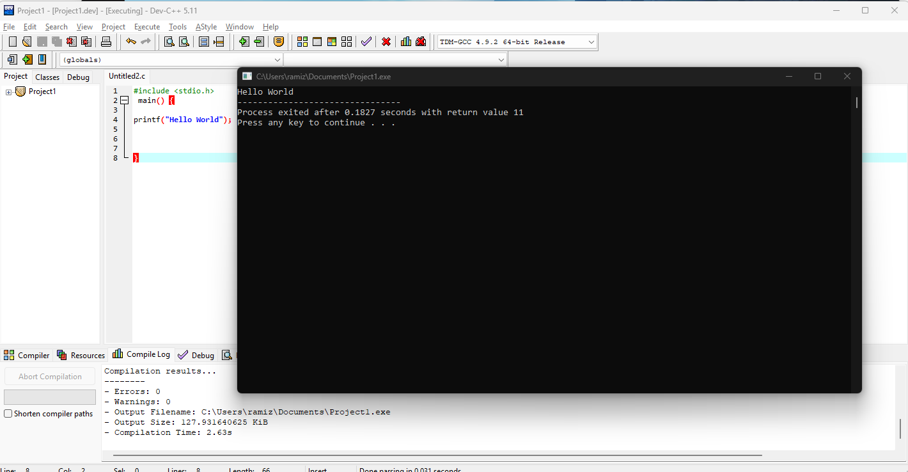

Task 3

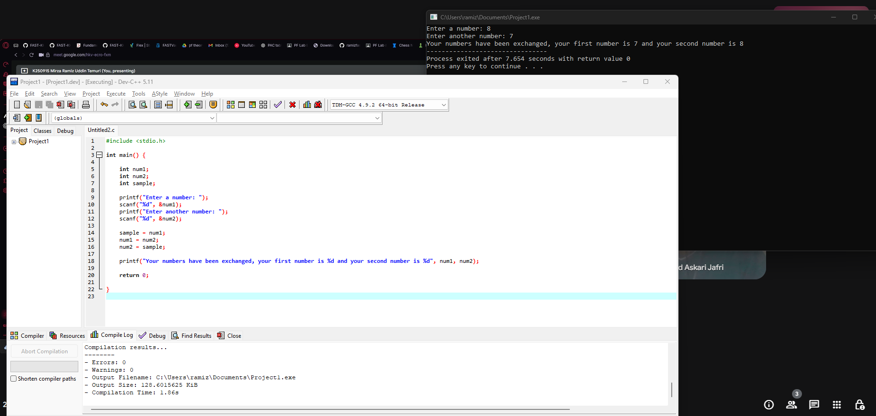

#include <stdio.h>

int main() {

int num1;
int num2;
int sample;

printf("Enter a number: ");
scanf("%d", &num1);
printf("Enter another number: ");
scanf("%d", &num2);

sample = num1;
num1 = num2;
num2 = sample;

printf("Your numbers have been exchanged, your first number is %d and your second number is %d", num1, num2);

return 0;

}

